**Summary of Chapters 4 and 5 from book Immuno-Biology (Janeway, 8th edition)**

(almost) All figures are copied from the book.

Prepared by Milca Tarshish

(October 2019)

**Table of Content:**

1. B-cells and T-cells – general overview 2

2. B-Cells structure 3

3. T-Cells structure 6

4. B-Cells construction from genes 8

5. T-Cells construction from genes 14

6. Secondary diversification of the antibody repertoire 16

# B-cells and T-cells – general overview

B-cells and T-cells are 2 types of lymphocytes in the immune system.

There are many differences and similarities between T-cells and B-cells, some of which are mentioned in the bellow table. This document will describe some of them (and others) in more details.

|  |  |  |  |
| --- | --- | --- | --- |
| **Attribute** | **B-cells** | **T-cells** | **Similar/differ?** |
| Origin | Bone marrow | Thymus | Differ |
| Bind to | Antigens | Antigen fragments | Differ |
| Include constant region | Yes | Yes | Similar |
| Include variable regions | yes | yes | Similar |
| Go through V(D)J recombination | Yes | Yes | Similar |
| Go through somatic hypermutations | Yes | No | Differ |
| Use MHC molecules to bind to antigens | No | Yes | Differ |
| Use RSS at V(D)J recombination | Yes | Yes | Similar |

.

# B-Cells structure

Antigen binds to a B-cell Antigen Receptor -BCR.

Antibody molecules have 2 major roles:

1. Bind to antigens – is done by the V region of the Y shape antibody. This region varies between antibodies.
2. Bind to effector molecules and cells that destroy antigens – is done by the stem part (C region) of the Y shape antibody. This region is less variable between antibodies.

Antibody structure:

1. It has 2 identical heavy chains, and 2 identical light chains.
2. The C region can be one of 5 different classes: IgM (μ), IgD (δ), IgG (ϒ), IgA (α) and IgE (ε).
3. Light chains can be either one of 2 types: λ (lambda) or κ (kappa). In each antibody – both light chain will be of same type. In humans the average of κ: λ is 2:1.
4. Can bind 2 identical antigens.
5. The interaction between the binding site and the antigen is called affinity.
6. Heavy chain and light chain connected with disulfide bonds:

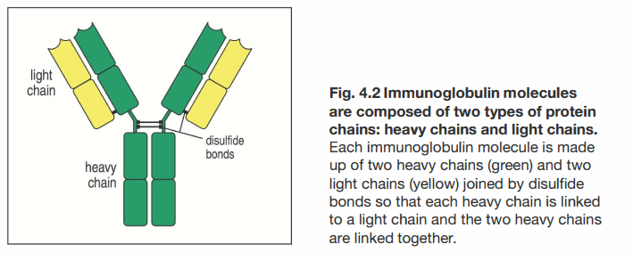

1. Both the C region and the V region are built from part of both heavy and light chain as depicted bellow:

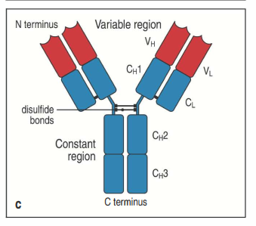

Immunoglobin domain

This is a structure of about 110 Amino acids. 2 such exists in each light chain, and 4 such exist in the heavy chain:

1. VL and CL – are the Immunoglobin domains of the light chain.
2. VH, CH1, CH2, CH3 - are the Immunoglobin domains of the heavy chain.
3. VL and VH – are in the variable domain
4. CL , CH1, CH2, CH3 – are in the constant domain
5. All Immunoglobin domains are similar to each other, but not identical.
6. Antigen binding is done by the end part of the VL and VH.

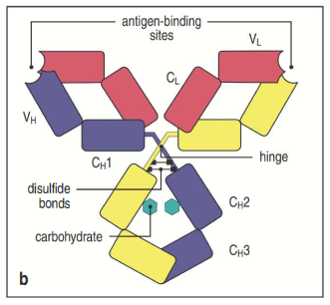

Interaction of antibody with Antigen

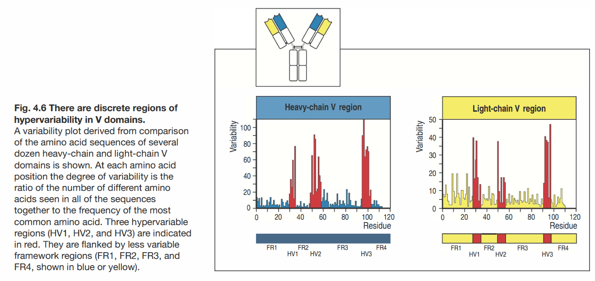

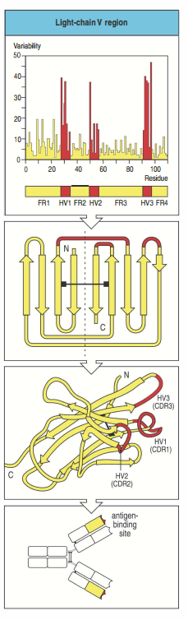Antigen binding Site: The location in the antibody where a specific antigen can bind to. Called also – antibody combining site.

CDRs: Complementary Determining Regions: The 6 hypervariable regions (3 in light chain and 3 in heavy chain). The combination of all 6 HV sites (Hypervariable sites) – will determine the final antigen specifity.

Combinatorial diversity: The ability to generate different combinations of heavy chain and light chain V regions.

Epitope/Antigenic determinant: The small structure in the antigen, which is recognized by the antibody.

Conformational/discontinuous epitopes: Epitopes that are composed of amino acids from different sites of the polypeptide.

Continous/Linera epitopes: An epitope composed of a single segment of polypeptide chain.

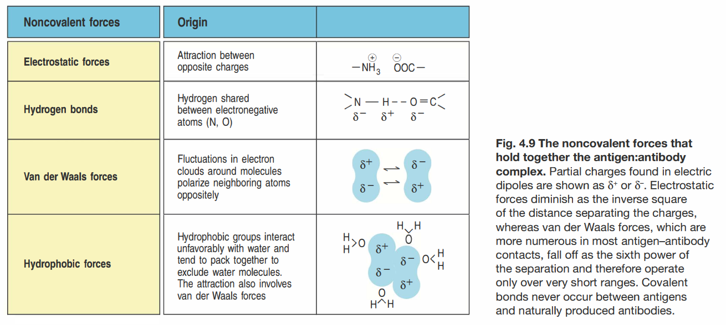

# T-Cells structure

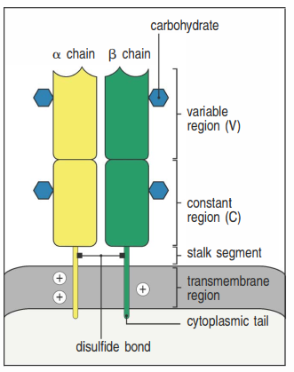T-cell can act either as killer, activator or regulator.

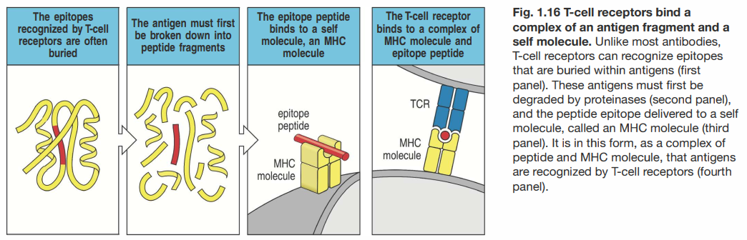Unlike B-cells receptors which bind to a whole antigen outside the cell, the T-cell receptors (TCR) bind to antigen particulars (peptide fragments) placed on the surface of the cell. These antigens peptide fragments are placed on the cell surface by MHC molecules.

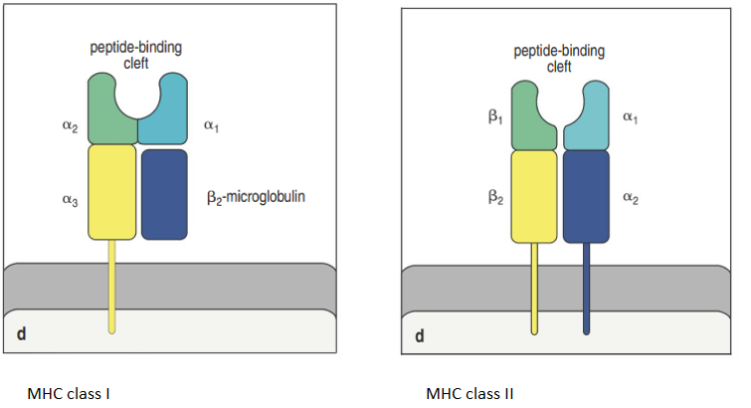MHC molecules

In both MHC classes – the paired protein domain near the membrane resemble the immunoglobulin domain, while the 2 others form together a groove – where the peptide bonds to.

MHC (Major Histocompatibility Complex) molecules: highly polymorphic genes that encode the cell surface protein essential for the [acquired immune system](https://en.wikipedia.org/wiki/Acquired_immune_system) to recognize foreign molecules in [vertebrates](https://en.wikipedia.org/wiki/Vertebrate).

CD8 T-cells: Cytotoxic killing cell.

CD4 T-cells: Helper cells - send signals to other types of immune cells, including CD8 killer cells, which then destroy the infectious particle

MHC class I

Built of a longer α chain encoded in MHC which are a set of genes located on chromosome 6, and a shorter chain β2-microglobulin chain encoded on chromosome 15 and none-polymorphic. Only α chain spans the cell membrane. Peptides that bind to MHC class I are usually short – 8-10 amino acids long. Are recognized by CD8 molecules. MHC class I molecules present peptides from pathogens, commonly viruses, to CD8 cytotoxic T-cells which are specialized to kill any cell that they specifically recognize.

MHC class II

Built of similar length α chain β chain – both encoded from MHC. Both α and β chains span the cell membrane. Peptides that bind to MHC class II are usually longer – 13 and more amino acid long. Are recognized by CD4 molecules. The main function of CD4 T-cells that recognize MHC class II molecules –is to activate other effector cells of the immune system. When CD4 T cells recognize peptide bound to MHC class II molecules on B cells – they stimulate the B cell to produce antibody. Similarly, CD4 T cells recognizing peptide bound on MHC class II molecules on macrophages, activate these cells to destroy the pathogens in their vesicles.

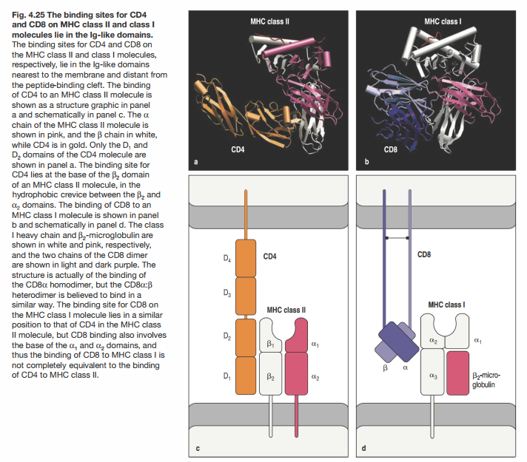

# B-Cells construction from genes

Germline configuration: The immunoglobulin and T cell receptor loci as they exist in the DNA of germ cells and of all somatic cells in which somatic recombination has not occurred.

Somatic recombination: Gene recombination that is not in the meiosis stage.

V(D)J recombination: A type of somatic recombination that occurs in the development of lymphocytes, that recombines different gene segments into sequences encoding complete protein chains of immunoglobin and T-cell receptors.

See also following movie that explains V(D)J recombination: <https://www.youtube.com/watch?v=3rAgZylOEB4&list=PLNxPv76KnZ8PsulAwTXDnTqJjb2cKioDJ&index=11&t=0s>

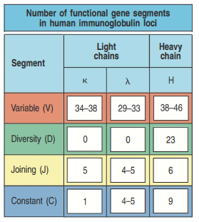The 3 sets of Immunoglobulin chains are: Heavy chain, light chain of type λ and light chain of type κ. The gene segments that encode these chains are organized into 3 clusters (called genetic loci): The λ, κ, and the heavy chain loci, each of which can assembly a complete V-region sequence.

λ light chain locus is located in chromosome 22.

κ light chain locus is located in chromosome 2.

Heavy chain locus is located in chromosome 14.

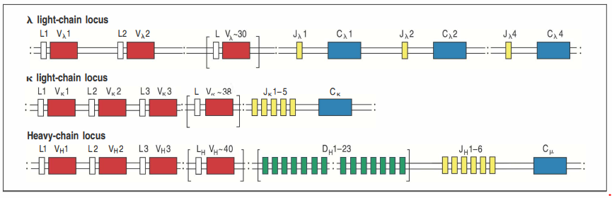The arrangement of the above gene on the chromosomes is described below:

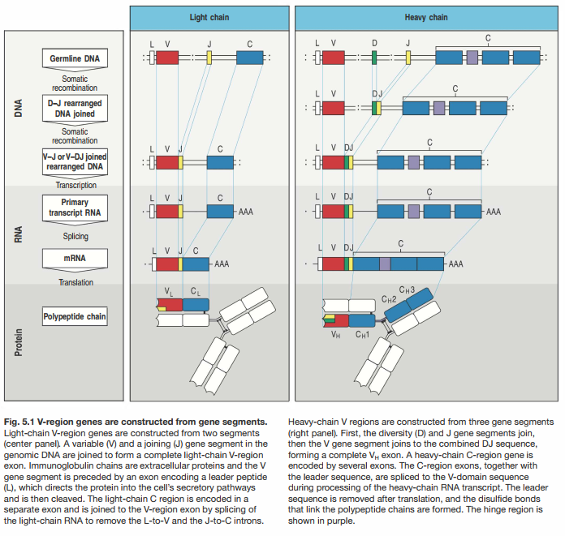

Rss: Recombination signal sequences. Those are sequences that guide the DNA rearrangement of V(D)J recombination. They are none coding sequences, located adjacent to the point where recombination takes place (V D or J gene segments). The RSS are built of “Heptamer-space-nonamer” as shown below, where the “space” is of size 12 or 23 base pairs (bp). The 12/23 rule states that a gene segment flanked by by an RSS with 12 bp pairs typically can be joined only to one flanked by a 23-bp spacer Rss. DH genes have 12-bp RSS on both size, thus will prevent a VH gene to join to a JH gene in the heavy chain. This is depicted below:

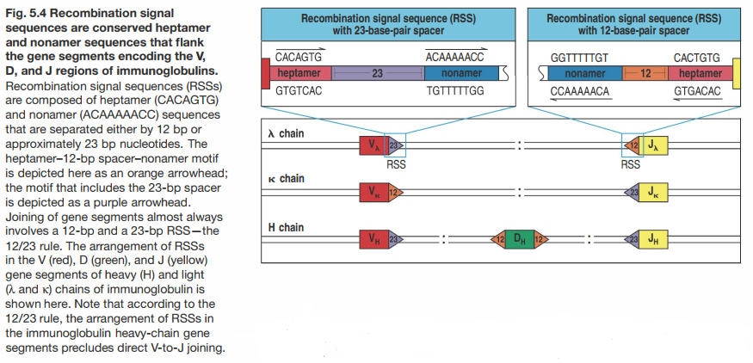

CDR1 and CDR2 are encoded from the V-gene segments, and CDR3 is encoded by the additional DNA sequence that is created by the joining of the V and J gene segments for the light chain, and the V, D and J segments for the heavy chain.

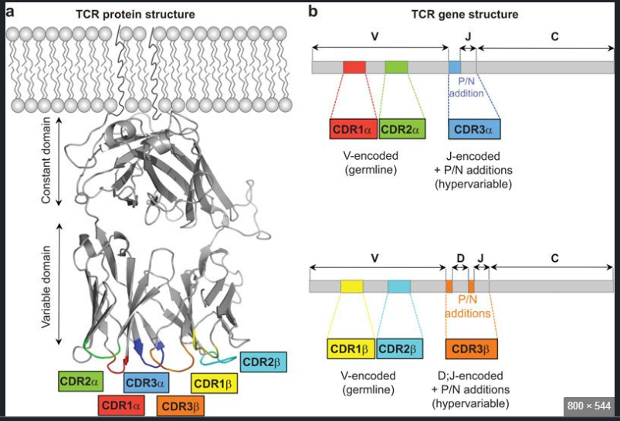

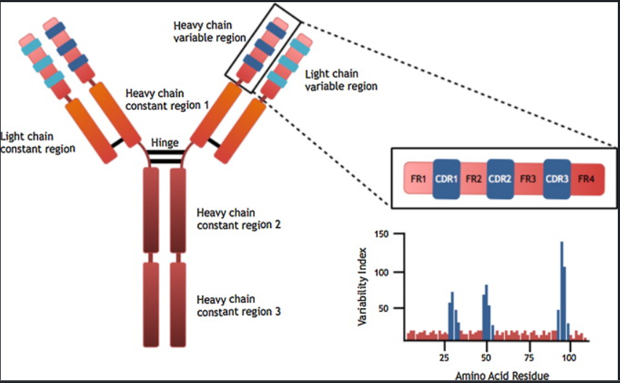

A few proteins are involved in the VDJ recombination (like RAG1 and RAG2). The below is a schematic of the process:

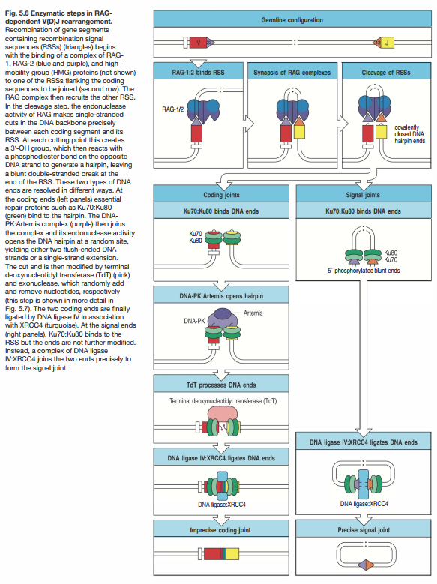

B-cell Diversity:

The following factors contribute to the diversity of Immunoglobulin repertoire:

1. There are multiple different copies of each type of segments (V, D, J)
2. The combination of V-D-J can vary.
3. Junctional diversity, which is the addition and subtraction of nucleotides at the joint between each 2 gene segments.
4. Combinations of heavy and light chains.
5. Somatic hypermutations

|  |  |  |  |
| --- | --- | --- | --- |
|  | κ light chain | λ light chain | Heavy chain |
| V segments | 40 | 30 | 40 |
| D segments | --- | --- | 25 |
| J segments | 5 | 4 | 6 |
| Total | 200 | 120 | 6000 |

As can be seen above – there is a total of 200+120=320 combination of light chains, and 6000 combination sof heavy chains. This sums up to a total of 6000x320=1.9x106 different antibody molecules.

The above is the combinations of 1 & 2 above. The RAG proteins are the proteins that are required to catalyze these rearrangements.

If we add to that the junction diversity (3 above) – this can sum up to about 1011 different receptors.

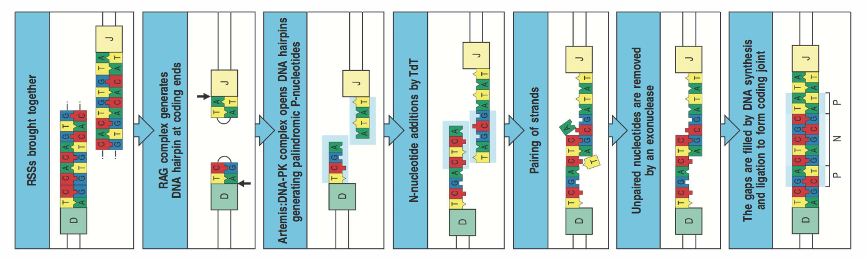CDR1 and CDR2 are encoded by the V-gene segment, and CDR3 is falls at the joint between V-gene segment and J-gene segment, and at the heavy chain it is partially encoded by the D-gene segment. In both light and heavy chain – the diversity of CDR3 is is significantly increased by the addition and deletion of nucleotides at 2 steps, while the formation of the junction between gene segments. The added nucleotides are called P-nucleotides and N-nucleotides. As the total number of nucleotides is random – the added nucleotides often (2 out of 3 cases) disrupt the reading frame of the coding sequence beyond the joint. Such frameshift will lead to none functional proteins. This DNA rearrangement is called “noneproductiverearrangement”.

# T-Cells construction from genes

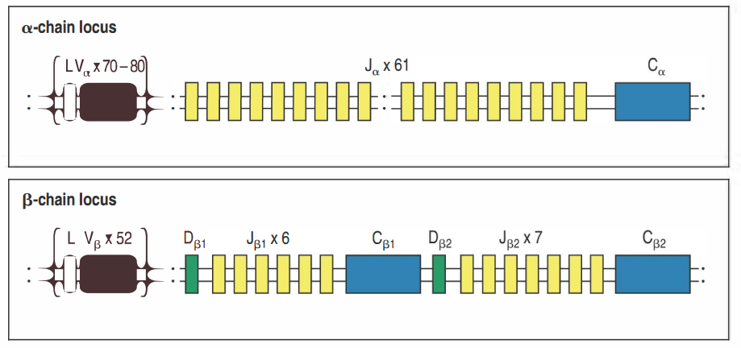As can be seen in the figures here – recombination of α and β chains in T-cells are similar to the ones of the heavy and light chain of B-cells.

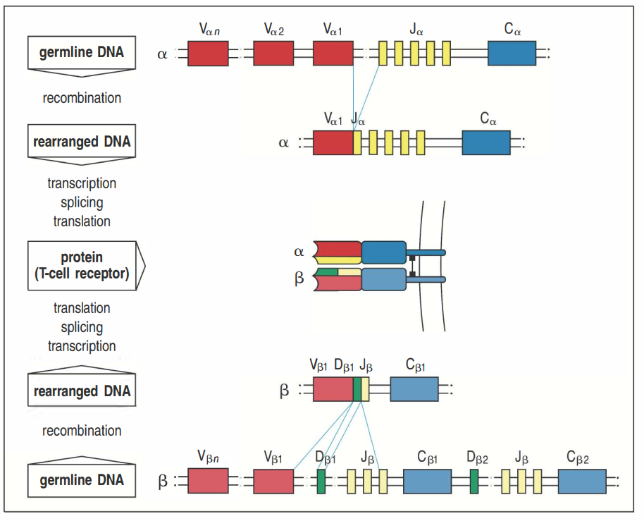

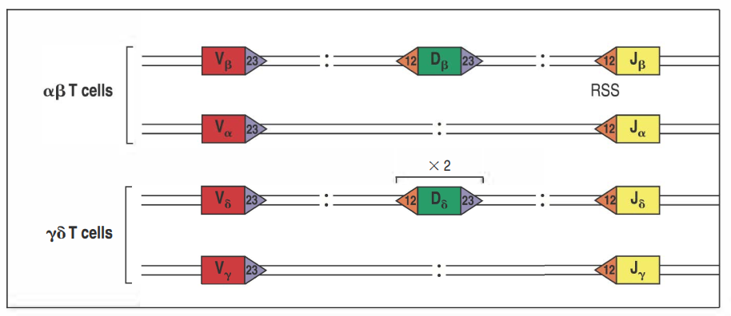

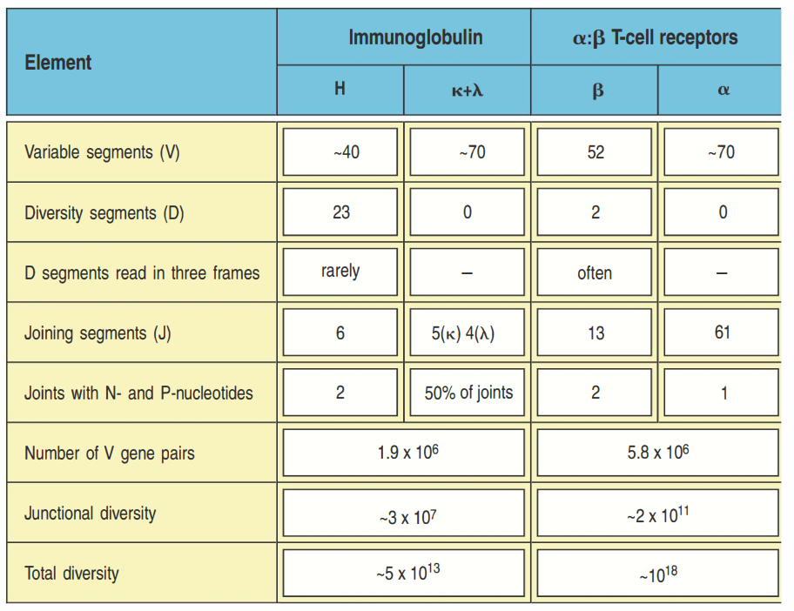

T-cells have much more diversity than B-cells due to much more J genes, and the larger diversification at the junction between gene segments during gene rearrangements.

On the other hands T-cells do not have somatic hypermutations on their V regions after rearrangements, as B-cells do.

# Secondary diversification of the antibody repertoire

RAG mediated V(D)J recombination, happening in the bone marrow, are responsible of the primary repertoire of immunoglobulin, and happen without B-cells interacting with antigens.

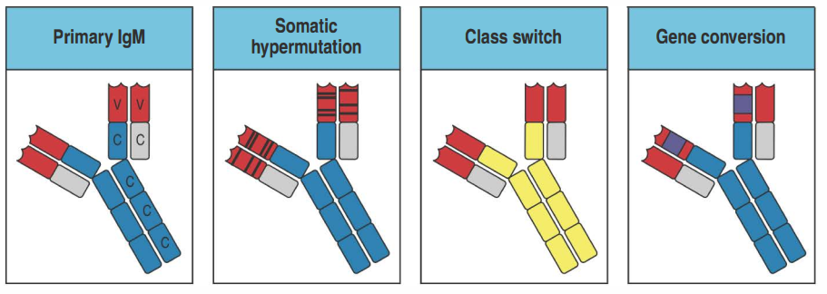The Secondary phase of diversifications occurs in active B-cells, and is largely driven by antigens. It is achieved through 3 mechanisms:

1. Somatic hypermutation
2. Class switching or class switching recombination
3. Gene conversion.

All the above occur only in activated B-cells, and not in T-cells, and are initiated by an enzyme (gene) called AID – Activation Induced Cytidine Deaminase. Also they require signals from activated T-cells.

Structural variation in immunoglobulin constant regions

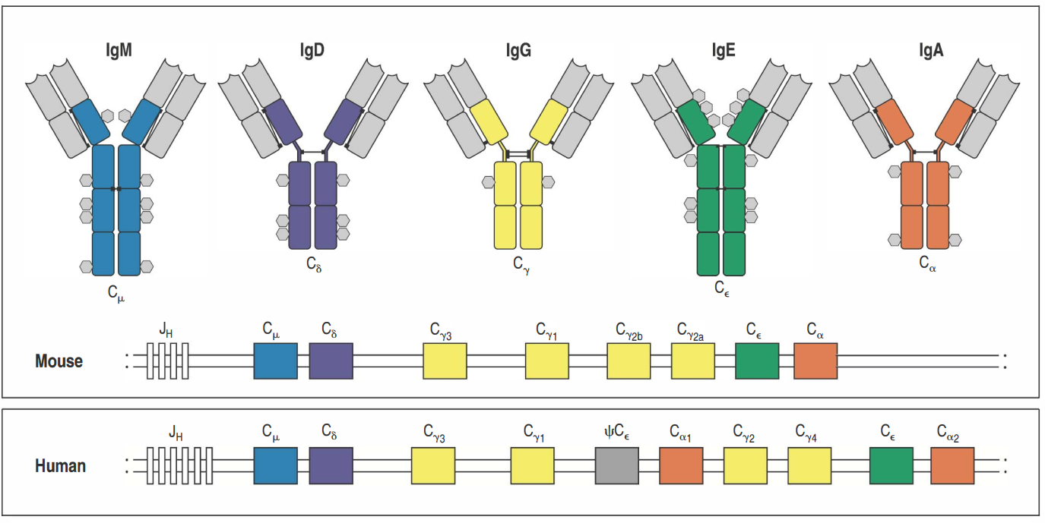The C regions in T-cell receptors have the functionality of supporting the V-region and anchoring the molecule in the membrane. The C regions of B-cells can be made as both transmembrane receptor and secreted antibody. The C regions of antibodies are crucial to their diverse effector function.

There are 5 types of C regions, as described in different colors here, some of which (IgG and IgA) – have additional sub-classes. Each class has a specific effector different function.

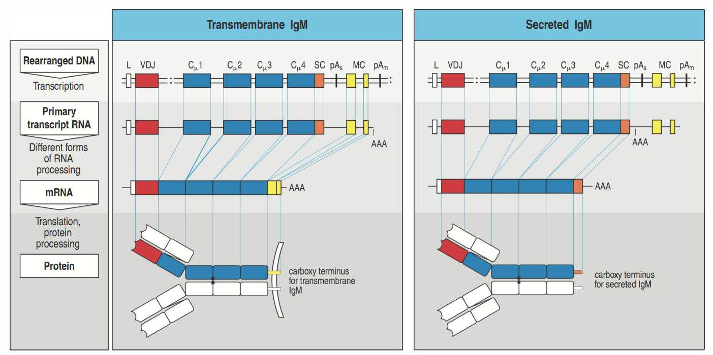Immunoglobulin of all classes can be produced either by a membrane bound receptor or as secreted antibody. All B-cells initially express the transmembrane for of IgM. Their progeny can produce IgM antibodies, or can go through “class switch” to express transmembrane immunoglobulin of a different class, which then can be followed by production of secreted antibodies of this new class. Alternate RNA splicing forms either transmembrane or secreted antibody. Example for this alternate RNA splicing is shown here for IgM, but is the same for all other classes.

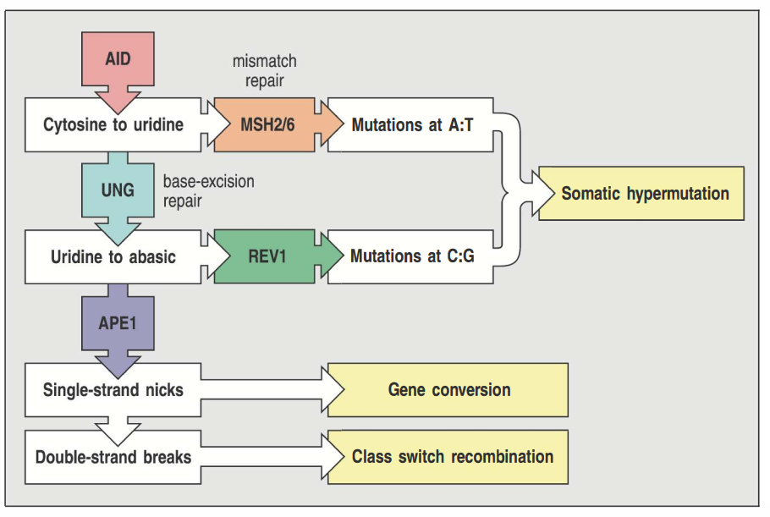

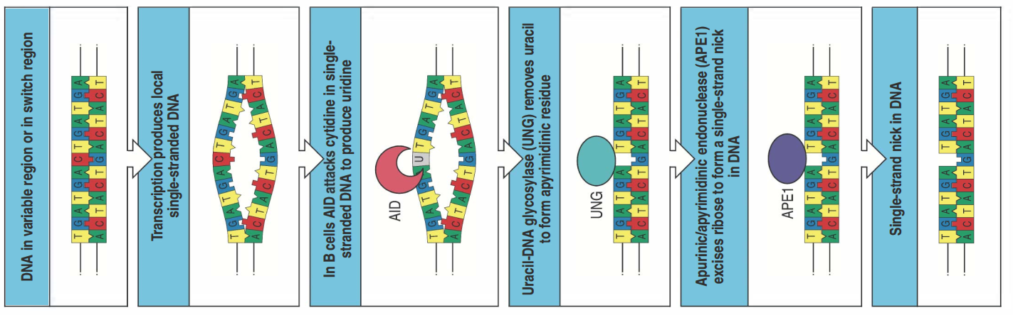

Mutations in the framework that change amino acids and basic immunoglobulin structure – will mostly be selected against.

Mutations in the CDR regions – that will increase the affinity for antigen – are positively selected and favored for survival.

Note that T-cell receptors do not go through somatic hypermutation like do B-cells.

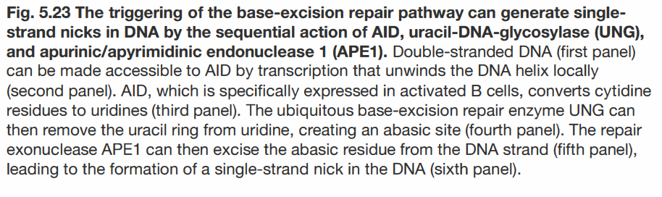

Class switching happens after antigen stimulation, and not in the bone marrow like V(D)J recombination. It is always productive (meaning ending with a protein), and not random, but rather directed by external signals. Class switching does not affect the V-region, and thus does not affect the antigen specificity, but rather affects the effector capacities.

Isotype switching is also described in following movie:

<https://www.youtube.com/watch?v=gyTHXjVUPWw&list=PLNxPv76KnZ8PsulAwTXDnTqJjb2cKioDJ&index=12&t=0s>

